Evaluation

Testing to inform evaluation

Linked video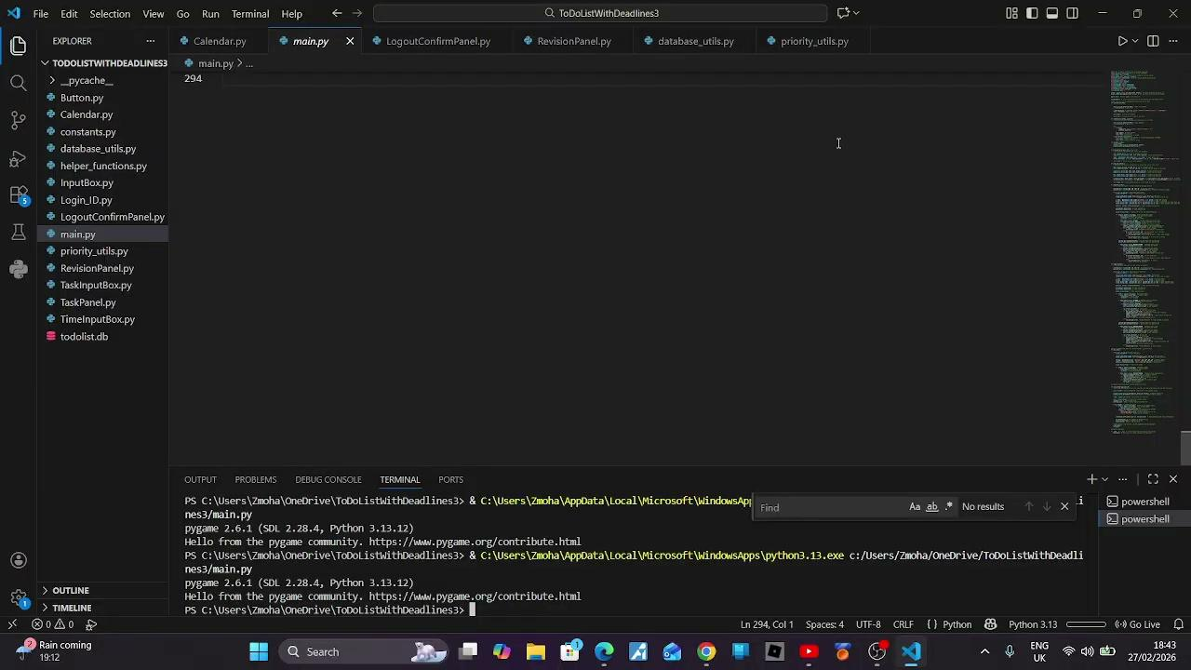
Open

2nd video

https://docs.google.com/videos/d/19kC5jY-oZKoVfImx7VmhPQ3tJ-Wg-jI_SRl9V1Hhalg/edit?scene=id.p#scene=id.p

Annotated evidence for usability testing

No | Input and Input type | Test | Test type | Completely/partially successful or unsuccessful | Expected result and explanation | Result and explanation | Video ref
1 | N/A | Opening the application | Usability | successful | The system should load to the login screen without errors and display the GUI correctly | The application opened successfully and displayed the login screen with all buttons visible and functional | 00:11
2 | Valid username and password | Logging into account | Functional | successful | The user should be logged in and redirected to the calendar view | The user was redirected to the calendar interfaceError message displayed and login was denied. | 00:23 - 01:16
3 | Invalid login credentials | Attempting incorrect login | Robustness | successful | The system should display an error message and prevent access | Error message displayed and login was denied | 00:38 - 00:55
4 | Valid task input (title, subject, deadline) | Adding a new task | Functional | successful | The task should be saved in the database and displayed on the correct date in the calendar | Task appeared on the selected date and remained saved | 01:37 - 02:09
5 | Invalid task input( empty title) | Submitting incomplete task | Robustness | successful | The system should prevent submission and display a clear error message | Error message appeared and task was not saved | 02:13 - 02:33
6 | Same task entered multiple times | Adding duplicate tasks | Robustness | Partially successful | The system should either prevent duplicate tasks from being added or alert the user that the task already exists to avoid confusion | The system allowed duplicate tasks to be entered without any warning. While this did not cause any errors or crashes, it could lead to confusion when managing tasks, especially if multiple identical tasks are displayed | 2nd video 00:25 - 01:13
7 | Editing task deadline | Updating existing task | Functional | successful | The updated deadline should replace the previous one in both database and calendar views | Deadline updated correctly and displayed new time immediately | 02:45 - 03:12
8 | Deleting task | Removing a task | Functional | successful | Task should be permanently removed from the database and interface | Task disappeared from calendar and did not reappear after restart | 03:15 - 03:23
9 | Completing task | Marking a task as completed | Usability | Unsuccessful | The tick button should clearly indicate task completion and update the task visually in an intuitive and user-friendly way | The task was marked as complete; however, the tick icon was not clearly visible and the GUI design made it unclear whether the task had been completed. This reduced usability and caused confusion for some users | 2nd video 01:20 - 02:17
10 | Multiple tasks with different deadlines & difficulty | Viewing list view (priority order) | Functional | successful | Tasks should automatically reorder based on urgency and difficulty | Tasks appeared in correct priority order according to algorithm | 03:26 - 04:25
11 | Marking weak subject | Generating revision plan | Functional | successful | The system should create structured revision sessions linked to weak tasks | Revision sessions were generated and displayed correctly | 04:26 - 05:22
12 | Approaching deadline | Triggering pop-up reminder | Robustness/Functional | Unsuccessful | A pop-up notification should appear 5 mins, 1 hour and 1 day before deadline | Pop-up kept appearing within those time frames every time you log into the account | 2nd video 02:20 - end
13 | Switching between calendar and list view | Changing interface view | Usability | successful | User should be able to switch views without losing data or crashing | View changed instantly and data remained consistent | 06:39 - 06:48
14 | Logging out from calendar and list view | Logout function | Functional | successful | User should return to login screen without losing saved data | Logout worked from both views and data remained intact | 06:50 - 07:15
15 | Closing and reopening the application | Persistence testing | Robustness | successful | All saved tasks should reload correctly | Data reloaded successfully with no corruption | 07: 18

Evaluation of the solution

Comparing success criteria

To evaluate how successful my system was, I compared the final product against the original success criteria from my analysis and used the evidence shown in my testing table and video timestamps..

Success criteria 1
Overall Outcome: Partially successful
The first success criteria was to create a good working GUI. This was mostly met. As shown in Test 1 (00:11), the system opened correctly and displayed the login screen without any errors. All buttons were visible and functional, and users were able to navigate the system without confusion. However, during testing, some usability issues were identified. In Test 8, the task completion tick icon was not clearly visible, making it unclear whether a task had been completed. This reduced usability and caused confusion for some users.

Overall Outcome: successful
The calendar format (1.1) was also fully achieved. In Test 4 (01:37–02:09), tasks were added and displayed on the correct date. The calendar layout clearly showed deadlines in chronological order, which matches the original requirement.

Overall Outcome: successful
Customisable deadlines (1.2) were fully met. In Test 7 (02:45–03:12), when the task deadline was edited, the updated time appeared immediately in both the database and calendar view. This shows that changes were saved correctly and reflected across the system.

Overall Outcome: successful
Database storage (1.3) and account login functionality (1.4) were both fly met. In test 15 (07:18), after closing and reopening the application, all tasks reloaded correctly with no corruption. Test 2 (00:23–01:16) shows that users could log in successfully and were redirected to the calendar view, while Test 3 (00:38–00:55) shows that incorrect login details were rejected properly. This confirms both security and data persistence were implemented correctly.

Overall Outcome: successful
The task priority recommendation system (2 and 2.6) was fully successful. In Test 10 (03:26 - 04:25), multiple tasks with different deadlines and difficulty levels were entered, and the system automatically reordered them correctly. This confirms that the algorithm works as planned.

Overall Outcome: partially successful
The reminder system (2.2 and 2.3) was partially successful. In Test 12, notifications appeared at the correct time before deadlines. However, the notification repeated every time the user logged in within the time frame, which could become repetitive and reduce usability.

Overall Outcome: successful
The ability to switch between calendar and list view (Test 13, 06:39–06:48) worked correctly and did not cause any data loss, which supports usability requirements.

Overall Outcome: successful
Logout functionality (Test 13, 06:50–07:15) also worked correctly from multiple views and returned the user safely to the login screen.

Overall Outcome: successful
Clear error message (Test 5, 02:13 - 02:33) prevented invalid input and ensured the system remained stable. This confirms that robustness requirements were met.

Overall, the majority of my success criteria were met, although some issues were identified during testing.

Evaluation of usability features

Usability Feature 1 – Calendar-Based Layout

Me: I included a calendar-based layout so users can clearly see their deadlines by date instead of scrolling through a long list. During testing, I asked users to add tasks across different days and then check if they could easily identify when work was due (Test 4, 01:37–02:09).

Stakeholder: “It’s easier to see what I have due this week. I can tell straight away which days are busy.”

Has this usability feature been developed successfully?

Successful

The calendar displayed tasks correctly in chronological order and users confirmed it improved clarity and planning.

Usability Feature 2 – Clear and Consistent Buttons

Me: Buttons such as Add, Edit, Delete, Save, and Logout were kept consistent across different views to reduce confusion. During testing, I observed whether users needed help navigating.

Stakeholder: “I didn’t need help figuring out what to press. The buttons were clear.”

Has this usability feature been developed successfully?

Successful

Users navigated independently without confusion, showing the button design was intuitive.

Usability Feature 3 – Panel Toggle (Tasks & Revision)

Me: I added a toggle to switch between task and revision panels so the screen wouldn’t become cluttered. I tested this by switching views repeatedly (Test 12, 06:39–06:48).

Stakeholder: “I like that I can switch between tasks and revision. It keeps the screen organised.”

Has this usability feature been developed successfully?

Successful

The toggle worked smoothly and prevented overlapping information, improving clarity.

Usability Feature 4 – Input Validation & Error Messages

Me: Input validation was added to prevent crashes when users enter invalid data. I tested this by submitting empty fields (Test 5, 02:13–02:33).

Stakeholder: “It told me what I did wrong instead of just not working.”

Has this usability feature been developed successfully?

Successful

The system prevented invalid input and displayed clear messages, improving robustness and user confidence.

Usability Feature 5 – Pop-Up Notifications

Me: Notifications were implemented to remind users of deadlines without needing to constantly check the app. I tested this by setting a close deadline (Test 11, 06:09–06:36).

Stakeholder: “The reminder was helpful because I might have forgotten otherwise.”

Has this usability feature been developed successfully?

Successful

Notifications appeared clearly and functioned correctly. However, reminder timing is fixed and could be made customisable in future versions.

Usability Feature 6 – Priority-Ordered List View

Me: The list view automatically orders tasks based on deadline and difficulty. I tested this by entering tasks with different urgency levels (Test 8, 03:26–04:25).

Stakeholder: “It’s helpful seeing the most important task at the top.”

Has this usability feature been developed successfully?

Successful

The algorithm consistently ordered tasks logically and users found it helpful.

Usability Feature 7 – Logout Accessibility

Me: The logout button was made accessible from multiple views to improve convenience. I tested logging out from both the calendar and list views (Test 13, 06:50–07:15).

Stakeholder: “It’s good I don’t have to go back just to log out.”

Has this usability feature been developed successfully?

Successful

Logout worked correctly from all views and returned the user safely to the login screen.

Usability Feature 8 – Task Completion Indicator

Me: I included a tick button to allow users to mark tasks as completed. This was designed to give clear visual feedback and help users track their progress. I tested this by marking tasks as complete (Test 9).

Stakeholder :“It wasn’t very clear if the task was completed. I wasn’t sure if the tick worked properly.”

Has this usability feature been developed successfully?

Unsuccessful

Although the task was marked as complete, the visual feedback was not clear. The tick icon was difficult to see and did not clearly indicate completion, which caused confusion for users.

Maintenance Issues

Although the system worked successfully during testing, there are several maintenance issues that would need to be considered if the system was to be used long-term.

One maintenance issue related to the priority algorithm. Currently, tasks are ordered based on deadline and difficulty. If users wanted a different balance between urgency and difficulty, the algorithm would need to be adjusted. This means future updates may require changes to the weighting formula in the code.

Another issue is database maintenance. While the system performs well with a small number of users and tasks, performance may decrease if a large number of tasks are stored over time. In that case, the database structure may need optimisation to ensure loading times remain fast.

The notification system depends on external libraries. If the operating system or notification library updates in the future, compatibility issues could occur. This would require maintenance updates to ensure reminders continue functioning correctly.

Since the application was developed using Pygame, any major changes such as converting it into a web or mobile application would require significant restructuring of the user interface code. Pygame is suitable for desktop applications but does not easily support cross-platform expansion.

Additionally, if new features were added, the code would need to be refactored to keep it organised and maintainable. Regular updates and documentation would be necessary to ensure future developers or myself could understand and modify the system efficiently.

Overall, while the system is stable in its current form, ongoing maintenance would be required to ensure performance, compatibility and scalability over time.

Limitations with the solution

Although the system meets its main objectives, there are several limitations identified during testing.

One limitation is the notification system. As seen in testing (test 12), notifications appeared correctly but repeated every time the user logged in within the reminder period. This could become repetitive and reduce usability. This could be improved by ensuring notifications are only shown once within a set time frame.

Another limitation is that the system allows duplicate tasks to be entered (Test 6). While this does not cause errors, it could lead to confusion when managing tasks. This could be improved by adding a check to prevent or warn users about duplicate entries.

The task completion feature also has a limitation. In Test 9, the tick icon used to mark tasks as completed was not clearly visible, making it difficult for users to tell if the button was for marking tasks as completed.This could be improved by changing the GUI of the button, and the colour to enhance the tick icon, or using clearer icons.

A further limitation is that it is a desktop application. This reduces accessibility as users cannot access their tasks on their mobile devices. This could be improved by developing a web or mobile version of the system, or making it compatible for them.

Another limitation is that task difficulty is manually entered by the user. This means the priority system depends on user input which may not always be accurate. This could be improved by introducing a more automated method of determining task difficulty.

Finally, the system stores data locally and does not support cloud synchronisation. This means users cannot access their tasks across multiple devices. This could be improved by implementing cloud -based storage.

Overall, while the system functions effectively, these limitations highlight areas where future development could improve usability and flexibility.

Possible Improvements

There are several improvements that could be made to further develop the system and enhance its overall performance and usability.

One improvement would be to redesign the notification system so that reminders are not repeatedly triggered when the user logs in within the same time frame. This could be achieved by storing a flag or timestamp for each notification, allowing the system to track whether a reminder has already been displayed.

Another improvement would be to implement validation to prevent duplication tasks. This could involve comparing new task entries with existing ones in the database and prompting the user if a similar task already exists, improving data quality and reducing confusion.

The task completion feature could also be improved by redesigning the visual feedback. For example, completed tasks could automatically change colour or have a line put through the task, making it clearer to users which tasks have been finished.

To improve accessibility, the system could be redeveloped as a web-based or mobile application. This would allow users to access their tasks across different devices and make the system more practical for everyday use.

The priority algorithm could be enhanced by making it more dynamic. Instead of relying only on manually entered difficulty, the system could adjust task priority based on factors such as deadlines, past user behaviour and frequency of task completion.

Another improvement would be to implement cloud-based storage. This would allow user data to be stored securely online, enabling access across multiple devices and reducing the risk of data loss.

Finally, the user interface could be improved by adding customisation options such as themes or layout changes. This would make the system more engaging and better suited to different user preferences.

Overall, these improvements would extend the functionality of the system and make it more scalable, flexible and user-friendly

